**Homicide and Unemployment in North America and Latin America: A Comparative Analysis**

**Group 4: Vaishnavi Paineni, Sindhuja Baikadi, Veda Sahaja Bandi**

**Final Project Report**

1. **Introduction**

This report presents an exploration of homicide rates and unemployment in North and Latin America through a series of interactive visualizations built on an HTML page. Leveraging rich datasets and carefully chosen visual attributes, we unveil hidden trends, compare and contrast regional patterns, and offer a nuanced understanding of the interplay between these social and economic indicators.

1. **Why and How**

**2.1 Task Intended to be Done with the Visualization**

This project utilizes interactive visualizations to explore the relationship between homicide and unemployment rates across various countries and timeframes. By employing graphical exploration, we aim to unveil hidden patterns, uncover potential correlations, and foster a deeper understanding of these interconnected socio-economic indicators.

**2.2 Visualization Techniques**

The project incorporates several visualization techniques inspired by Edward Tufte's principles and Tamara Munzner's design concepts:

**1. Geospatial Representation:**

Utilizes different geographical projections (Azimuthal, Albers, Mercator, Natural Earth, Equal Earth, Conic Equal Area, Equirectangular, Orthographic) to accurately depict the spatial distribution of Homicide Rates. We have used **Geo Albers** for our project.

**2. Color Encoding:**

Employs a color scale to encode Homicide Rates, facilitating the interpretation of intensity variations. The color scale, based on Tufte's principles, enhances the visual perception of the data.

**3. Tooltip Interaction:**

An interactive tooltip is implemented across various charts, providing users with detailed information upon hovering over specific data points. The tooltip displays key metrics such as country, year, Homicide Rate, and Unemployment Rate, enhancing the user's ability to explore the dataset.

**4. Temporal Trends:**

Presents temporal trends using line charts. Each line represents the trend of Homicide and Unemployment Rates over the years, allowing for a temporal analysis of the data.

**5. Position Encoding:**

Position encoding is a fundamental technique employed across scatter plots, bar charts, and column charts. It involves mapping data attributes to spatial coordinates on axes. For scatter plots, Unemployment Rates are positioned on the X-axis, and Homicide Rates on the Y-axis. In bar and column charts, the X-axis typically represents years, while the Y-axis represents Homicide and Unemployment Rates, respectively.

**6. Mark Types:**

Different mark types are utilized based on the chart type. Circular marks are used in scatter plots to represent individual data points. Vertical bars are employed in bar charts to depict Homicide Rates for each year, and vertical columns in column charts represent Unemployment Rates over time.

**7. Interactive Legend:**

Interactive Legends are integrated seamlessly across scatter plots, bar charts, and column charts. Users can select specific years from the legend, dynamically updating the charts to focus on relevant data points. This feature enhances user exploration, allowing for effortless comparison of Homicide and Unemployment Rates across different temporal periods.

**2.3 Proposed Deliverables**

The proposed deliverables for this project are:

**1. Geospatial Map:** Representation of the homicides and unemployment rates on a geospatial map.

**2. Hover Trend Chart:** Trend Chart for every country (detail on demand for geospatial maps). Visualization of homicides and unemployment rates for a particular country when hovered over it.

**3. Trend Chart:** Trend Chart for the selected country with visualization of homicides and unemployment rates for that particular country along with detail on demand.

**4. Column Chart:** Column Chart for Homicides for the selected country with visualization of homicide rates for that particular country.

**5. Bar Chart:** Bar Chart for the unemployment rates for the selected country with visualization of unemployment rates for that particular country.

**2.3.1 Relation between Visualizations:**

The visualizations work together to provide a thorough understanding of the relationship between homicide and unemployment rates in North and South America. The geospatial map offers an overview of the data across different countries. When a user interacts with the map, hoverable trends provide detailed insights for a specific country. Comparative trends enable users to compare how the trends are affecting each other in specific countries. The distribution visualizations offer a focused view of homicide and unemployment rates, respectively. This integrated approach allows users to explore both broad trends and detailed country-level data seamlessly.

**2.3.2 Interaction between the user:**

The interaction between the user and the visualization will help the user discover the trend charts by hovering over the country in the geospatial map which further gives detailed information.

The user can filter for a year to get detailed trend information while interacting with the trend charts, allowing users to explore year-by-year data.

The user can view how the homicides and unemployment rates are changing over the years and the exact value for a particular year when hovering in the trend chart.

1. **WebPage Design**

**3.1 Geospatial Map**

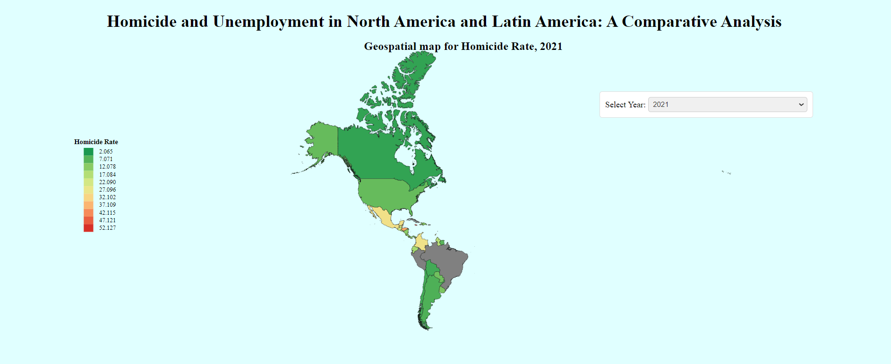

**Figure 1: Geospatial Map**

* **Axis:** GeoProjections with appropriate scaling based on the chosen projection method.
* **Marks:** Countries are represented by paths on the map, allowing for clear identification and comparison.
* **Encodings:** Color encoding to represent Homicide Rates, enabling users to quickly grasp the intensity of rates across different regions.

**3.2 Hover Trend Chart**

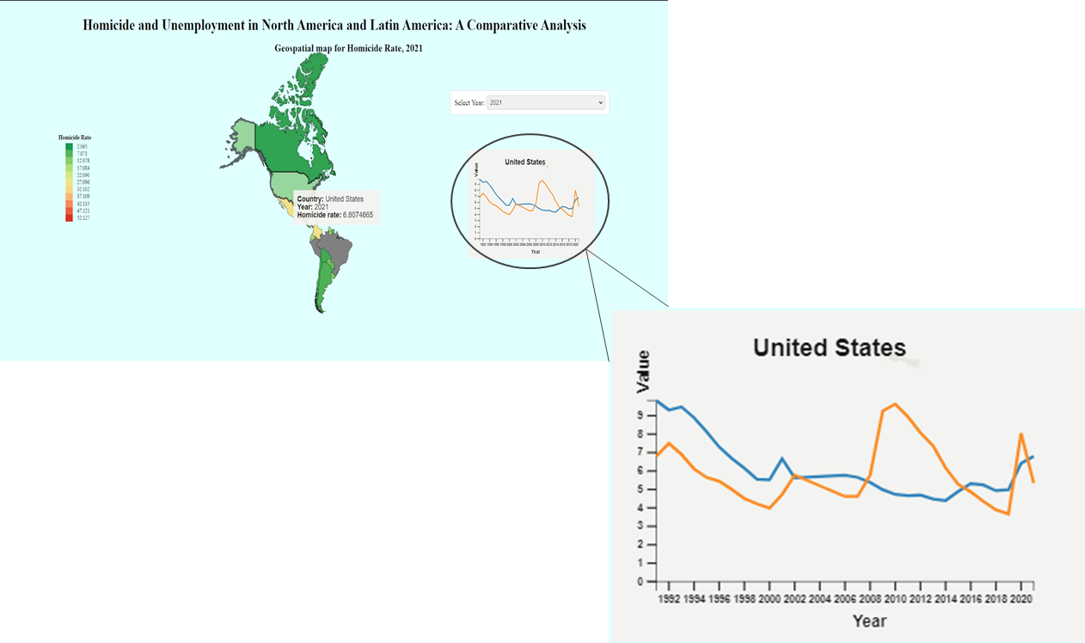

**Figure 2: Hover Trend Chart**

* **Axis:** Time on the x-axis, Homicide, and Unemployment Rates on the Y-axis.
* **Marks:** Circles represent data points along the temporal axis.
* **Encodings:** Different colors signify Homicide and Unemployment Rates, ensuring a quick understanding of trends. This design enhances the user experience by providing a focused exploration of temporal dynamics for each country.

**3.3 Trend Chart**

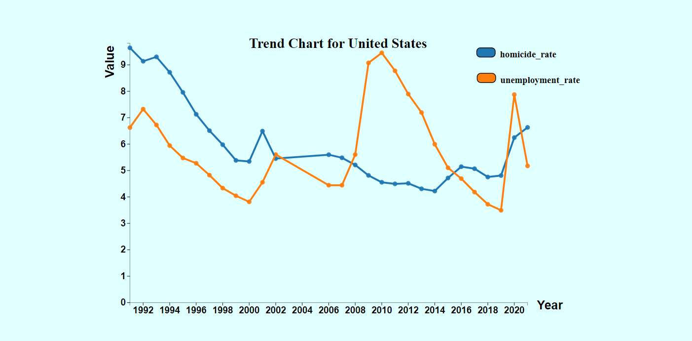

**Figure 3: Trend Chart**

* **Axis:** Time (Year) is represented on the X-axis, and Homicide and Unemployment Rates are on the Y-axis.
* **Marks:** Lines depicting the trends of Homicide and Unemployment Rates over a specific period.
* **Encodings:** Color encoding for different trends, enhancing the ability to distinguish between multiple lines. Data points provide specific information for each year.

**3.4 Scatter Plot**

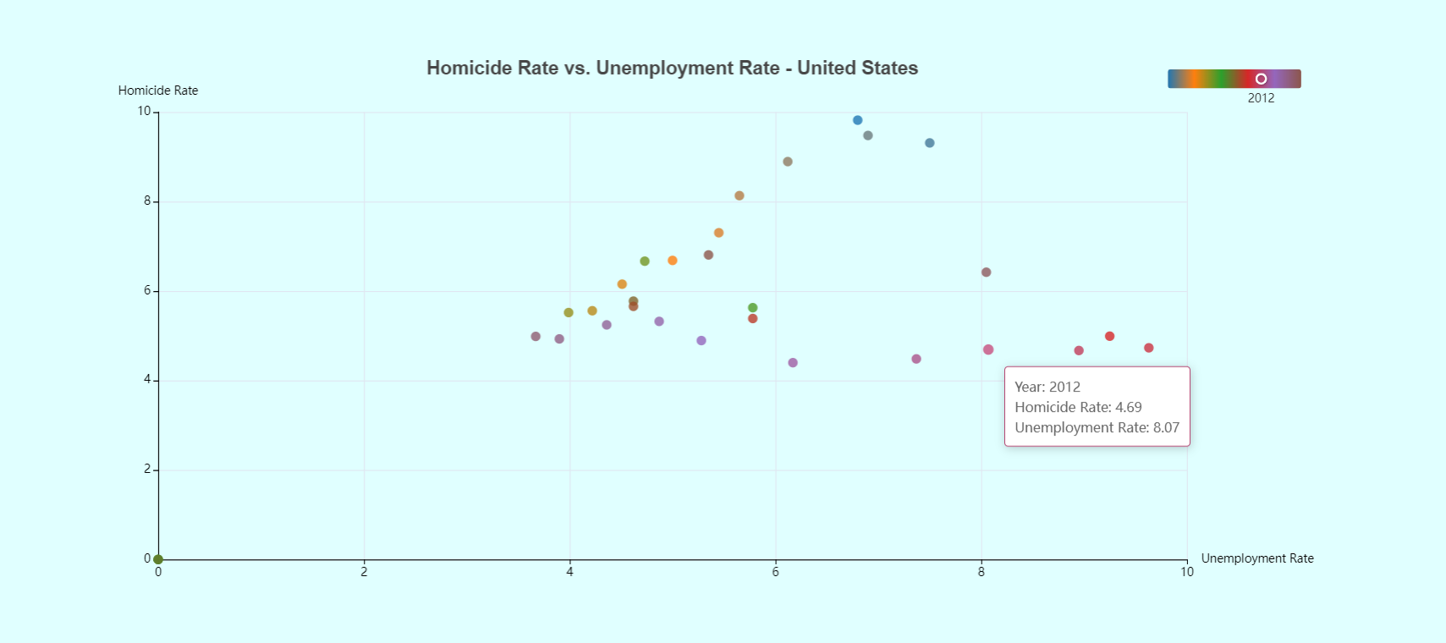

**Figure 4: Scatter Plot**

* **Axis:** The horizontal axis represents the Unemployment Rate and the Vertical axis represents the Homicide Rate. Scales are dynamically adjusted based on the dataset's range for clear visualization.
* **Marks:** Each data point is represented by a distinct mark on the plot. Marks are positioned according to the corresponding Unemployment and Homicide Rates, facilitating individual data point identification.
* **Encodings:** Color encoding is applied to each data point based on the chosen color scale. The color represents a specific year, aiding in the temporal interpretation of data points.

**3.5 Bar Chart**

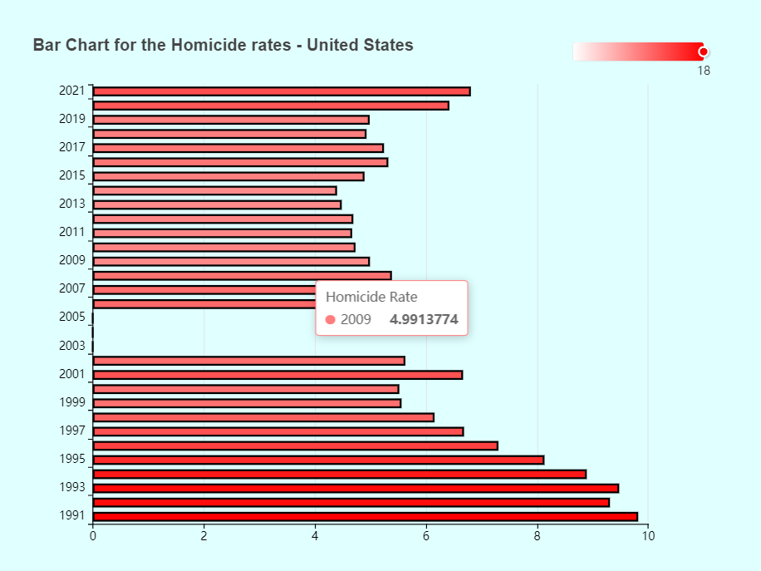

**Figure 4: Bar Chart**

* **Axis:** The vertical axis represents Homicide Rates, providing a clear quantitative scale for comparison.
* **Marks:** Bars represent individual countries, allowing for straightforward identification and visual contrast.
* **Encodings:** Color encoding is employed to depict Homicide Rates within each bar, facilitating a quick visual assessment of intensity variations across countries.

**3.6 Column Chart**

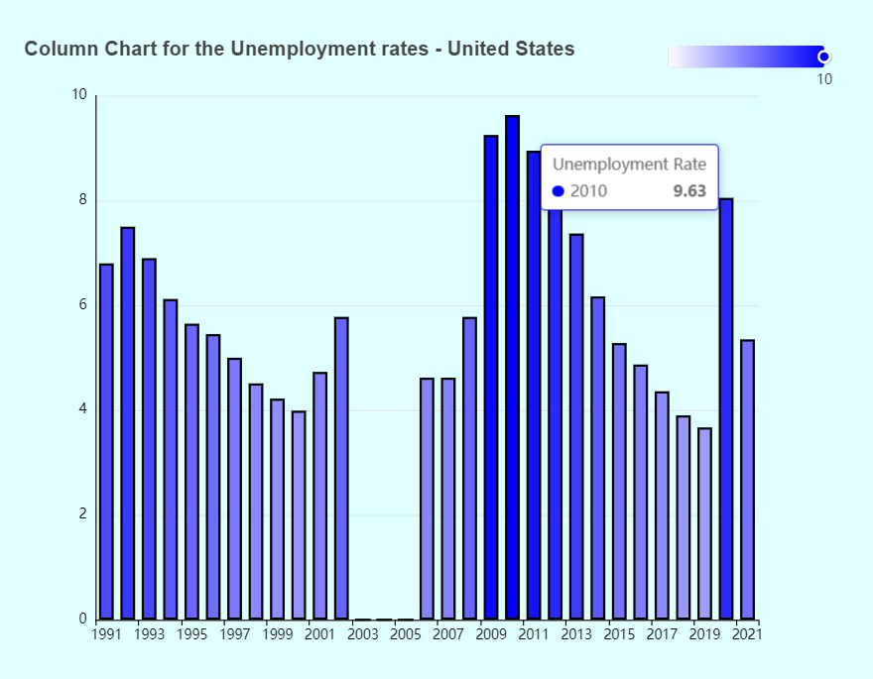

**Figure 5: Column Chart**

* **Axis:** Utilizes time-based X-axis and value-based Y-axis for representing years and Homicide/Unemployment Rates, respectively.
* **Marks:** Vertical bars act as marks, each corresponding to a specific year, facilitating easy visual comparison.
* **Encodings:** Applies color coding to the bars for clear distinction between Homicide and Unemployment Rates, enhancing visual clarity and quick comprehension.

1. **Goals Achieved:**

**1. Geospatial Representation:** Successfully achieved a clear and informative representation of Homicide Rates across different countries using various geographical projections.

**2. Temporal Trends:** Effectively visualized temporal trends through line charts, enabling users to identify patterns and fluctuations over time.

**3. Interactivity:** Implemented tooltips for detailed information, enhancing user interaction and providing additional insights.

**4. Filtering:** Implemented a year-based filter in the geospatial visualization, enabling dynamic adjustments of the homicide rate display as the selected year is modified.

**5. Enhanced Interaction:** Implemented a scatter plot feature triggered by clicking on a country in the geospatial map, revealing a visual representation of the correlation between the Unemployment Rate and Homicide Rate for the selected country.

**5. Obstacles**

**1. Slow Webpage Loading:** The large size of the geojson file led to slow loading times, potentially causing delays in accessing and viewing the visualizations on the webpage.

**2. Data Completeness:** Limited data for certain countries and years may impact the accuracy and comprehensiveness of the visualizations.

**3. Chart Overlapping:** In densely populated areas, labels and trend lines may overlap, affecting the visual clarity and readability of the charts.

**6. Limitations**

**1. Data Quality:** The accuracy of insights is dependent on the quality and completeness of the underlying data. Incomplete or inaccurate data may introduce biases.

**2. Generalization:** The visualization provides a high-level overview but may not capture specific regional nuances or localized factors influencing Homicide and Unemployment Rates.

**7. Future Work**

**1. Global Scaling:** Extend the analysis beyond North and Latin America, incorporating data from other regions and countries, enabling a more global perspective and comparative analysis.

**2. Enhanced Interactivity:** Explore additional features for users to customize views, allowing for a more personalized and interactive experience.

**3. Data Enrichment:** Incorporate additional socio-economic indicators to provide a more comprehensive analysis and better contextualization of Homicide and Unemployment Rates.

**4. Performance Optimization:** Address performance concerns to handle larger datasets, ensuring scalability and responsiveness.

**8. Conclusion**

The project has successfully met its primary goals, providing valuable insights into the spatial and temporal aspects of Homicide and Unemployment Rates. Despite existing limitations, ongoing efforts to improve data quality and visualization interactivity can contribute to the refinement and utility of the tool. Future work should focus on refining the user experience, incorporating additional dimensions of data, and optimizing performance for broader applicability. The project lays the foundation for a robust and informative exploration of socio-economic indicators, fostering a deeper understanding of their dynamics across countries and over time.

**9. References**

The downloaded the datasets with the following resources:

* Homicide dataset from <https://ourworldindata.org/>
* Unemployment dataset from <https://data.worldbank.org/>

Downloaded the topojson files for North and South America from

<https://github.com/myethiopia/NaturalEarth/tree/master/region_un/TopoJSON>